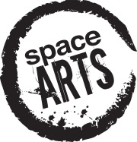 Space Arts Trust
Bursaries available for adult training
Space Arts Trust makes bursaries available to support adults, resident in West Sussex, who are aspiring artists, writers, musicians, actors, directors and dramatists to attend and participate in training courses, summer schools and professionally-run workshops. Bursaries would normally match equivalent funding already secured or committed as self-funding by the applicant. Full-time students are not eligible. Applications are welcome throughout the year.

For more details, please contact Liz Horne, Chair, Space Arts Trust at liz@franciscave.com .

Space Arts Trust is a registered charity and is financially supported by charitable donations; it receives no public funding.

